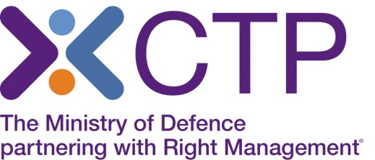

Virtual Classroom delivery of Finance for Non-Financial Managers

As you will be aware, with the situation around Covid-19, CTP is no longer able to deliver face to face classroom training, and therefore this course is being offered by Virtual classroom delivery. The Trainer will deliver this course using a webinar platform, to the same classroom group. You will be able to fully interact with the Trainer and the group, participate in group discussions and have a very similar experience to that of classroom training. There will be 3 shorter breaks, a lunch break, and training will finish at 16:00 each day.
In order to attend the training online, you will need access to a laptop or PC ideally at home, which has no firewall restrictions. Your laptop or desktop should have a microphone and speakers so that you can continue to interact with the Instructor, as you would within the classroom environment.
Training will take place via the Microsoft ‘Teams’ platform and there are further online details and system requirements on the Microsoft website https://support.office.com/en-us/article/join-a-teams-meeting-078e9868-f1aa-4414-8bb9-ee88e9236ee4 which will enable you to check that your IT meets the minimum requirements.
You will be prompted to download the Teams app or alternatively to simply ‘join on the web’ instead which does not require any software to be downloaded to your PC or laptop.
Course Joining Instructions will be sent to you and this will include your link to log in at 08:30 on day 1 to prepare for the course to commence at 09:00. The Trainer will take you through the platform controls at the start and you can send messages or speak directly to the Trainer if you have any issues.
Please note we will provide Ipso Facto with your name, email address and mobile number in order to register you on the Teams platform. Your mobile number would only be used where you are having technical difficulties and require assistance. If you do not wish for your number to be passed to Ipso Facto, please advise us by email.

If you wish to make a booking, please call our Course Booking and Information Centre on
01252 954007 and CTP staff will be happy to assist you.

