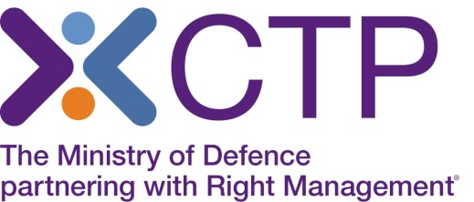

Virtual Classroom delivery of Enterprise and Self Employment

As you will be aware, with the situation around Covid-19, CTP is no longer able to deliver face to face classroom training, and therefore this course is currently being offered by Virtual classroom delivery. The Trainer will deliver this course using a webinar platform, to the same classroom group. You will be able to fully interact with the Trainer and the group, participate in group discussions and have a very similar experience to that of classroom training.
In order to attend the training online, you will need access to a laptop or PC ideally at home, which has no firewall restrictions. Your laptop or desktop should have a microphone and speakers so that you can continue to interact with the Instructor, as you would within the classroom environment.
Training will take place via Webex and there are further online details and system requirements on the Webex website (https://help.webex.com/en-us/nki3xrq/Webex-Meetings-Suite-System-Requirements) which will enable you to check that your IT meets the minimum requirements. We would be grateful if you could open up the test webex https://www.webex.com/test-meeting.html to ensure you can see the online platform test screen.

Course Joining Instructions will be sent to you and this will include your link to log in to the Webex platform on Day 1. The Trainer will take you through the platform controls at the start and you can send direct chat messages or speak directly to the Trainer if you have any issues.
Please note we will provide XForces with your name, email address and mobile number in order to register you for registration on the webex platform. Your mobile number would only be used where you are having technical difficulties and require assistance. If you do not wish for your number to be passed to XForces, please advise us by email.

If you wish to make a booking, please call our Course Booking and Information Centre on
01252 954007 and CTP staff will be happy to assist you.

