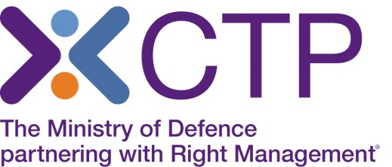
Virtual Classroom delivery of Agile Project Management

As you will be aware, with the situation around Covid-19, CTP is no longer able to deliver face to face classroom training, and therefore this course is currently being offered by Virtual classroom delivery. The Trainer will deliver this course using a webinar platform, to the same classroom group. You will be able to fully interact with the Trainer and the group, participate in group discussions and have a very similar experience to that of classroom training.
You will be able to take the Foundation and Practitioner exams from home, if you have a webcam. You will need to provide ID and an invigilator will monitor you throughout the exam.
In order to attend the training online, you will need access to a laptop or PC ideally at home, which has no firewall restrictions. Your laptop or desktop should have a microphone and speakers so that you can continue to interact with the Instructor, as you would within the classroom environment. It is beneficial to have 2 screens where you can follow the Instructor and also read materials, however this is not essential to complete the course.
Training will take place via Webex and QA have further online details and system requirements on their website (https://help.webex.com/en-us/nki3xrq/Webex-Meetings-Suite-System-Requirements) which will enable you to check that your IT meets the minimum requirements to use webex. We would be grateful if you could read the details regarding virtual training https://www.qa.com/faqs/virtual-classroom/ and also open up the test webex https://www.webex.com/test-meeting.html to ensure you can see the online platform test screen.

Course Joining Instructions will be sent to you, and you will be registered to complete the online pre course learning.
Course materials will be sent by post, although e learning copies can be sent if required.

If you wish to make a booking, please call our Course Booking and Information Centre on
01252 954007 and CTP staff will be happy to assist you.

