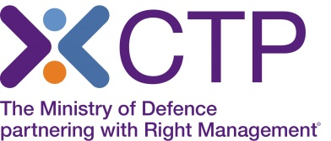
Virtual Classroom delivery of 6 Day APM Project Management Qualification

As you will be aware, with the situation around Covid-19, CTP is no longer able to deliver face to face classroom training, and therefore this course is currently being offered by Virtual classroom delivery. The Trainer will deliver this course using a webinar platform, to the same classroom group. You will be able to fully interact with the Trainer and the group, participate in group discussions and breakout rooms, view videos and boards, and have a very similar experience to that of classroom training.
You will be able to take the APM PMQ exam from home if you have a webcam. You will need to provide ID and an invigilator will monitor you throughout the exam.
Please note – as a classroom course, this 6 day course consists of 5 days training followed by attendance on the Monday to complete your exam. As a Virtual course, this will be 5 days of training with the exam scheduled for the following week.
In order to attend the training online, you will need access to a laptop or PC ideally at home, which has no firewall restrictions. Your laptop or desktop should have a microphone and speakers so that you can continue to interact with the Instructor, as you would within the classroom environment. It is beneficial to have 2 screens where you can follow the Instructor and also read materials, however this is not essential to complete the course.
Training will take place in most cases via the ‘Go to Meeting’ platform and system requirements can be found here https://support.goto.com/meeting/help/what-are-the-system-requirements-for-using-the-desktop-app-g2m090014
Note: Most devices have built-in speakers, but you will get better audio quality while connected via VoIP if you use a headset

We would be grateful if you could read the details regarding virtual training at https://www.quanta.co.uk/virtual-classroom-learning and also open up the test session to ensure you can view and hear the test https://support.goto.com/meeting/help/join-a-test-session-g2m050001
Course Joining Instructions will be sent to you, and you will be registered to complete the online pre course learning.
Course materials will be sent by post, although e learning copies can be sent if required.
If you wish to make a booking, please call our Course Booking and Information Centre on 01252 954007 and CTP staff will be happy to assist you.

