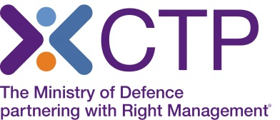
Virtual Classroom delivery of NVQ Assessor course.

As you will be aware, with the situation around Covid-19, CTP are very limited in the amount of delivery of face to face classroom training, and therefore this course is currently being offered by Virtual classroom delivery. The Trainer will deliver this course using a webinar platform, to the same classroom group. You will be able to fully interact with the Trainer and the group, participate in group discussions and breakout rooms, view videos and boards, and have a very similar experience to that of classroom training.
In order to attend the training online, you will need access to a laptop or PC ideally at home, which has no firewall restrictions. Your laptop or desktop should have a microphone and speakers so that you can continue to interact with the Instructor, as you would within the classroom environment.
Training will take place via the ‘Webex Training platform and system requirements can be found here:
Webex - https://help.webex.com/en-us/nki3xrq/Webex-Meetings-Suite-System-Requirements
Note: Most devices have built-in speakers, but you will get better audio quality while connected via VoIP if you use a headset. You will also require a webcam or similar functioning camera device.
The Tutor will send the Assessor Electronic Portfolio prior to the course starting along with the login details to access the virtual learning environment.
If you wish to make a booking, please call our Course Booking and Information Centre on 01252 954007 and CTP staff will be happy to assist you.
Course Joining Instructions will be sent to those who book.

