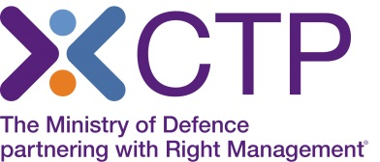
Virtual Classroom delivery of the Charity Management Awareness course

As you will be aware, with the situation around Covid-19, CTP is no longer able to deliver face to face classroom training, and therefore this course is currently being offered by Virtual classroom delivery. The Trainers will deliver this course using a webinar platform, to the same classroom group. You will be able to fully interact with the Trainers and the group, participate in group discussions and breakout rooms, view videos and boards, and have a very similar experience to that of classroom training.
Please note – the delivery of this course by virtual means is identical to a classroom course, this 5 day course is broken into the same learning units as the classroom variant and is also delivered by a number of sector specialists.
There is no exam or assessment for this course, the training provides understanding and knowledge transfer. In the current climate where charities are in the spotlight, the management of charities is evolving rapidly.
In order to attend the training online, you will need access to a laptop or PC ideally at home, which has no firewall restrictions. Your laptop or desktop should have a microphone and speakers so that you can continue to interact with the Instructor, as you would within the classroom environment.
Training will take place via GoTo Meeting software and further details can be found here:
Go To Meeting - https://support.goto.com/meeting/help/what-are-the-system-requirements-for-using-the-desktop-app-g2m090014
Note: Most devices have built-in speakers, but you will get better audio quality while connected via VoIP if you use a headset
If you wish to make a booking, please call our Course Booking and Information Centre on 01252 954007 and CTP staff will be happy to assist you.
Course Joining Instructions will be sent by email to those who book.

