EXHIBITOR REGISTRATION FORM

REGISTRATION TO EXHIBIT AT A CTP EMPLOYMENT FAIR
Thank you for your interest in exhibiting at our Employment Fairs. In order for us to process your booking request, please complete and return this form to CTPEvents@ctp.org.uk
CONTACT DETAILS
Company Name
Company Website
Company Address
 |  | Main Contact |  |  |  | Second Contact
Full Name
Job Title
Telephone
Email
COMPANY INFORMATION
✓ | Please tick one of the boxes below to indicate which category your organisation falls into:  If your organisation falls under any other category than those listed above, please email us to discuss further.
Employer (offering PAYE jobs) |  |  |  | Recruitment Company (offering live vacancies)
✓ | Please tick below which industry sector your organisation represents (as many as apply):
Administration, Secretarial |  |  | Accounting, Financial Services |  |  | Aviation, Aerospace
Building & Construction |  |  | Business Management |  |  | Catering & Hospitality
Education & Training |  |  | Engineering |  |  | Facilities Management
Health, Safety and Risk Management |  |  | Healthcare |  |  | IT & Telecoms
Leisure, Sport & Tourism |  |  | Manufacturing & Production |  |  | Public Sector
Retail |  |  | Security |  |  | Oil & Offshore
Transport & Logistics |  |  | Other (please state in the box)
INVOICING DETAILS – Provide a point of contact within your Accounts Department
Trading Name
Registered Company Number
Contact Name
Invoice Address
Telephone Number
Email
Purchase Order Number (if required)
EARLY BIRD OFFER! Receive 10% discount when booking 5 or more events in one transaction before 5th November 2021.
TERMS & CONDITIONS
We would like to draw your attention to our full terms and conditions on pages 3-7 for exhibiting at CTP Employment Fairs. Our payment term is within 30 days from the date of the invoice and if a booking is made within 30 days of the event taking place, payment is required prior to attending the event. Cancellations must be received in writing 28 days or more prior to an event for a full refund. Cancellations made within 28 days of the event taking place will not be eligible for a refund and your company will be liable to pay the invoiced amount in full.
Declaration - By entering your name in the box below and submitting this form you agree to the full terms and conditions and payment terms.

I have read and agree to the Terms and Conditions (enter your name)
NEXT STEPS
- Once your booking is accepted, you will receive an invoice as a notice of confirmation within 10 working days.
- Payment is required within 30 days of the date of the invoice.
- Your booking will include allocation of a stand with refreshments and lunch for 2 exhibitors (option 1) or 4 exhibitors (option 2).
- Our Event Co-ordinator will contact you prior to the event to collect more details of your requirement.
Please email your completed booking form to the CTP Central Events Team at CTPEvents@ctp.org.uk

EVENT DATES & LOCATIONS
✓ | Please tick the boxes below to confirm the events you would like to attend:
WEST MIDLANDS – 8th February 2022  The International Centre, Telford |  |  | SOUTH EAST – 7th July 2022  Newmarket Racecourse, Newmarket
SOUTH CENTRAL – 24th March 2022  Newbury Racecourse, Newbury |  |  | NORTHERN –22nd September 2022  The Centenary Pavilion Elland Road, Leeds
NORTH WEST – 28th April 2022  AJ Bell Stadium, Salford |  |  | SOUTH COAST – 6th October 2022  The AGEAS Bowl, Southampton
SCOTLAND – 18th May 2022  BT Murrayfield Stadium, Edinburgh |  |  | EAST MIDLANDS – 10th November 2022  Newark Showground, Newark
SOUTH WEST – 9th June 2022
Venue TBC
STAND OPTIONS
✓ | Stand options start from £450 (excluding VAT) as shown below.  - Option one includes lunch and refreshments for two delegates  - Option two provides lunch and refresments for four delegates  Please indicate below which stand size you require:
Option 1 – £450 (plus VAT) | Tick to select | Option 2 - £650 (plus VAT) | 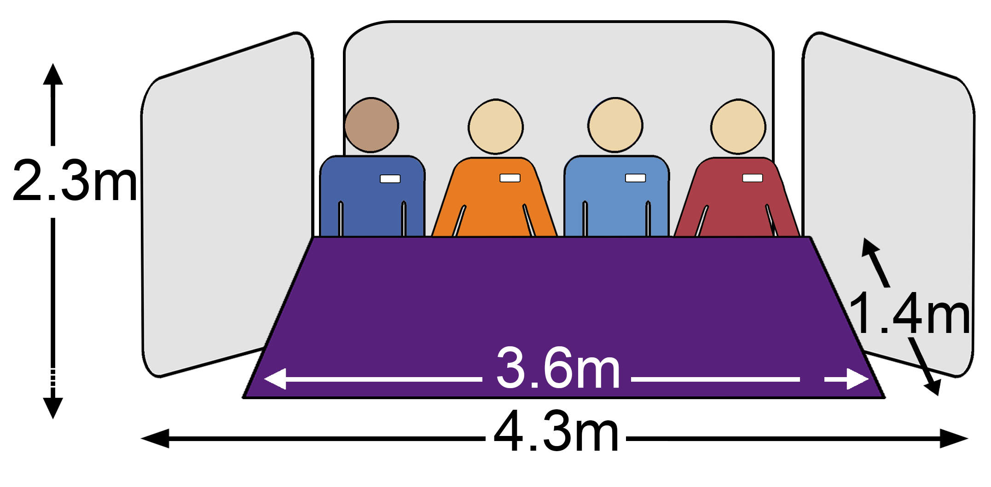  Tick to select
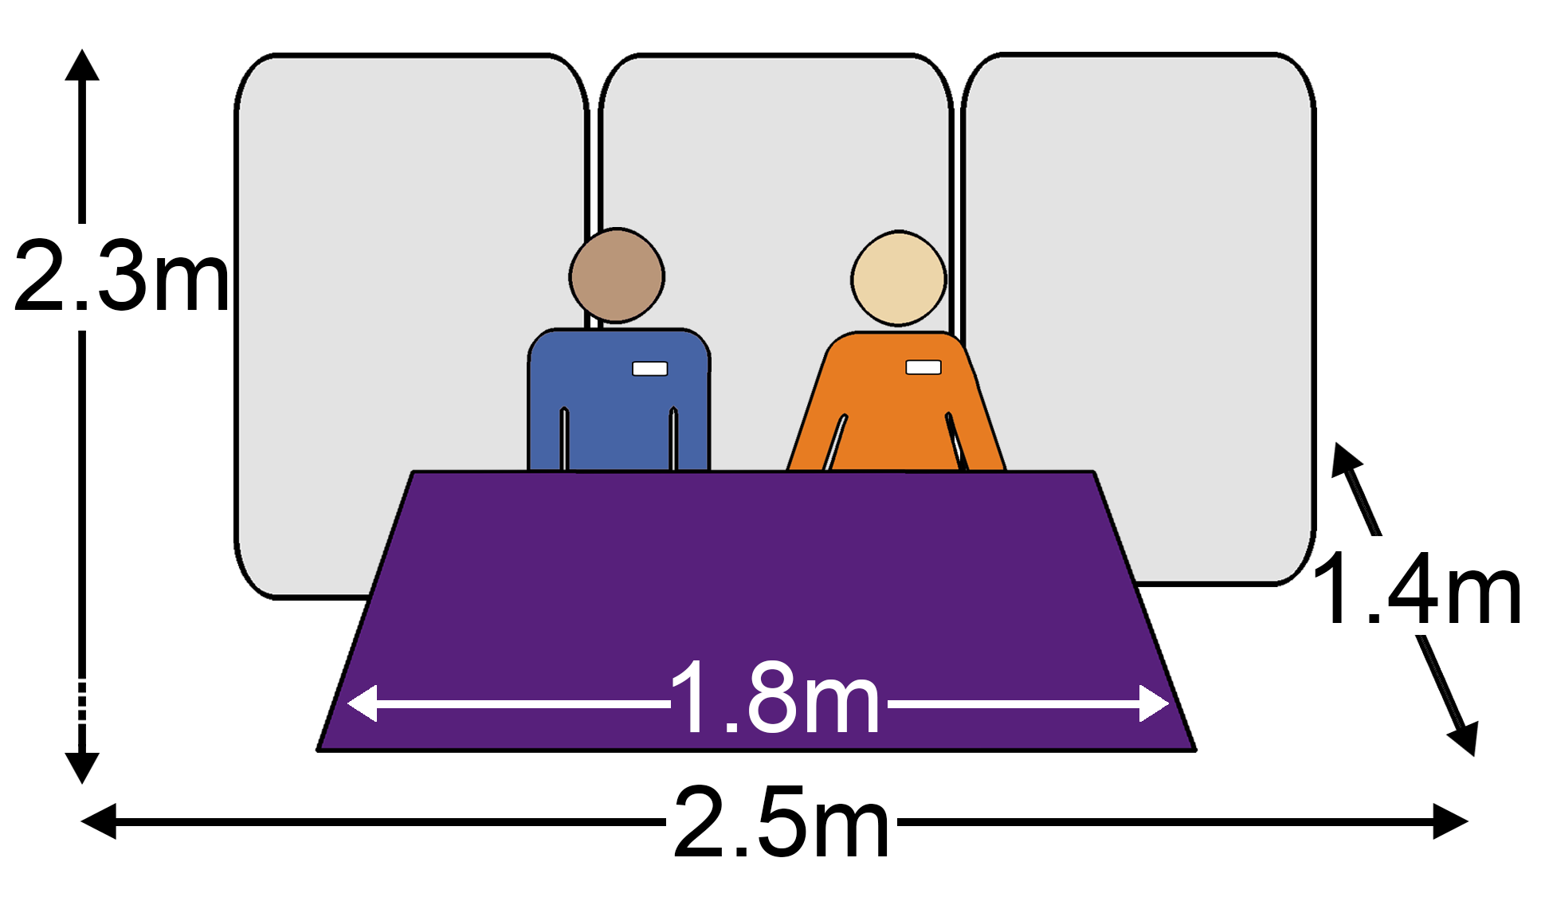

3.5 m² of space plus 2 delegates |  | 6 m² of space plus 4 delegates

TERMS AND CONDITIONS FOR EXHIBITORS AT
CAREER TRANSITION PARTNERSHIP EVENTS
Within these Terms and Conditions, “you” and “your” mean the persons signing the booking form as primary exhibitor and all other persons in the party who are representing the company which is exhibiting at a Career Transition Partnership (CTP) event (including anyone who is added or substituted at a later date). “CTP”, “we”, “us” and “our” mean Right Management Ltd, registered company number 01479160, and pertains to the Career Transition Partnership.

- Booking contract
  - You agree not to pass information gained during the event to other organisations.
  - You are willing to feedback to the CTP on applications to job vacancies advertised by you that are made by Service leavers as a result of attending the Employment Fair.
  - Submission of a completed booking form does not constitute confirmation of a stand until payment is made in full following issue of an invoice.
  - CTP reserves the right to select organisations to take part in Employment Fairs based on the selection criteria stated below. To meet the Service leavers expectations of the types of organisations they wish to be represented at our events, priority will be given in the following order:

- CTP registered employers
- CTP registered recruitment organisations
- Service support organisations
- CTP accredited preferred training provider (only if offering PAYE job opportunities)
- Industry Associations (by invitation)
- Resettlement Magazine Publishers (by invitation)
1.5 Definition of an approved recruitment company is one that is offering live PAYE job vacancies that meet the skills and experience of Service leavers, on behalf of a company by contract. They will be registered on RightJob and actively posting PAYE vacancies. Jobs-boards or generic recruitment agencies will not meet approval criteria. Final approval will be issued by a nominated CTP Employment Relationship Manager (ERM).
1.6 If you are representing a company who is an accredited preferred training provider to the CTP you will have current PAYE employment opportunities and attend the event to only publicise these job vacancies. Promotion of training courses to Service leavers is not permitted in any way. Job vacancies should not be on the condition that a job will or may be offered on completion of a training course undertaken with your organisation or any other training provider. If you are found to not be complying with these terms and conditions, you and your organisation will not be permitted to attend future CTP events. Refer also to point 1.8.
1.7 There are a limited number of stands allocated at each event for Service Support organisations, industry associations and resettlement magazine publishers who will be invited by a member of the Event Management Team or Regional Event Team.
1.8 Promotional materials, exhibition display stands and all other collateral must only represent your company branding and advertise job opportunities and you are not permitted to promote training at a CTP Employment Fair. Should your organisation contravene this, we reserve the right to request removal of the material(s) during the event and this may lead to suspension of attending CTP events in the future.
1.9 If an event is oversubscribed, a waiting list will be created. Organisations will be placed on the list according to the selection criteria. Space will be offered to those on the waiting list if additional space has been made available due to a cancellation.
- Payment

2.1 All prices exclude VAT at the current rate.
2.2 The cost of a stand at the event includes cold and hot refreshments, plus lunch for two exhibitors, per stand.
2.3 Payment terms in full are 30 days from the date of the invoice issued by CTP. Payments for events must be received by the date specified and the organiser may cancel the reservation and refuse the exhibiting company entry to the event.
2.4 Failure to pay within the terms stated will result in the exhibiting company being suspended from attendance at any other CTP events until payment is made in full.
2.5 If a booking is made within 30 days of the event taking place, payment is required prior to the event and should be made at the time of booking.
2.6 Payment may be made (in sterling) by cheque to Career Transition Partnership, credit card or via BACS, quoting the reference number stated on invoice issued.
BACS PAYMENT DETAILS | PAYING BY CHEQUE | CARD PAYMENTS
Career Transition Partnership  Barclays Banks  Knightsbridge Business Centre | Make cheques payable to:  Career Transition Partnership | May be taken over the telephone:  01252 954007
Account No: 90467049 | Remittance Address:  50 Bank Street,  Canary Wharf,  London, E14 5NS
Sort Code: 20-06-05
Payment Terms: 30 days from date of invoice
Exhibitor is to include the invoice number provided on all transactions and correspondence.

2.7 Any charges raised against us by your bank for handling dishonoured cheques, bank transfers or with any other payments will be passed on to you and you will be liable to reimburse us in respect of such charges within seven days.
3. Alterations or cancellation by you
3.1 Cancellation by you of your booking must be in writing. The effective date of cancellation is the date we receive written notification.
3.2 Cancellations made 28 days or more before the event will have any monies paid to us refunded in full.
3.3 Cancellations made within 28 days of the event taking place will not be eligible for a refund, regardless of whether representatives from your company attend on the day or not. Your company will be liable to pay in full, the amount invoiced from the information provided in your completed booking form.
4. Alterations or cancellation by us
  - In the event of unavoidable circumstances preventing us being able to fulfil our contracted obligations our liability should be limited to a refund of any monies paid to us for this event.

5. Media and Marketing
5.1 The CTP reserves the right to publish your company name and logo on websites, promotional material and in third party publications in order to further promote CTP events and in post-event articles, without any request being made direct to you.
5.2 Information which you are asked to provide on your company for the event booklet and website should be 60 words or more. CTP reserve the right to edit text if required due to design restrictions.
5.3 We may use quotes, photographs or film footage captured at employment events in publicity and marketing materials, including use on our website. Your attendance at an event may mean that you are featured in such media and you are deemed not to object. If you do not wish to be included in any photograph or footage, please notify the CTP Event Co-ordinator at the event, prior to the photographs or footage being taken.
5.4 Due to security considerations related to a Military event, exhibitors should refrain from promoting attendance at CTP events until after the event has taken place, particularly not to publish any details of the venue name and location on social media or website.
5.5 If you or your colleagues wish to organise any publicity or media coverage to promote your organisation attending a CTP event, you are requested to discuss with the CTP Head of Marketing Communications & Events prior to publication.
5.6 We will contact you post-event with an online survey to assess your satisfaction of attendance at the event and to measure how successful it was in terms of providing you with suitable candidates for your vacancies. We will appreciate your co-operation with completing the survey and feeding back your comments.
6. Liability
6.1 We do not accept liability for any loss or damage to property belonging to your company; or personal injury or death of you or any of your party, unless caused by proven negligence of the CTP.
6.2 The CTP is covered by all necessary public liability insurance and the Certificate of Insurance will be displayed at the event.
6.3 Any damages caused by your representatives must be reported to the CTP Event Co-ordinator and you may be required to reimburse costs of repair.
6.4 The CTP is not responsible for the safekeeping of any equipment or materials sent by you (either directly or through a courier, or other third party) to the venue ahead of, during or after the event. The security of such items is entirely your responsibility.
7. Your Responsibilities
7.1 You should apply using your company’s official registered name and should represent only that company. No other subsidiaries, sub-contractors or employers are permitted to exhibit or display promotional material unless specifically agreed with the CTP prior to the event.
7.2 CTP will allocate a stand position to you on the day of the event and you should not change spaces without prior permission from the CTP Event Co-ordinator.
7.3 You agree to set up and be fully ready before the declared opening time of the event, and to set down and vacate the venue promptly at the end of the event.
7.4 Some Service leavers attend our events to speak with specific companies and their assumption is they will be in attendance throughout the published times of the event. Should you wish to leave the event prior to the published finish time you are requested to discuss with the CTP Event Co-ordinator before dismantling your stand and leaving.
7.5 You should ensure your stand does not exceed the space allocated to you and CTP reserve the right to request this is adhered to during an event, should additional floor space be encroached upon.

7.6 If you are representing a training company you have agreed to exhibit as an employer/recruiter and are an accredited preferred training provider to the CTP. You will have current PAYE employment opportunities and attend the event to publicise these vacancies only and not to publicise training courses in any way. Job vacancies should not be on the condition that a job will or may be offered on completion of a training course undertaken with your organisation or any other training provider. If you are found to not be complying with these terms and conditions, you and your organisation will not be permitted to attend future CTP events.
7.7 If you are representing a recruitment company, you are there to recruit for specific PAYE job vacancies on behalf of other employers and not to “fish” for CVs. You are not to share personal details provided by Service leavers to any persons or organisations, without prior permission from the individual. If you are found to not be complying with these terms and conditions, you and your organisation will not be permitted to attend future CTP events.
7.8 If you are representing an industry body you are there to inform Service leavers about the industry you represent and offer advice on routes into the industry, required qualifications and job opportunities through your members. Promotion of paid-for memberships or other services is deemed inappropriate.
7.9 If you are representing a resettlement publication you are in attendance on the understanding that the event is an opportunity to promote your publication to Service leavers. Any approaches made to other exhibitors, particularly as potential advertisers, will be viewed as wholly inappropriate and will affect your opportunity to attend future events. We encourage you to promote any routes to employment you may have via your publication but also note that promotion of training providers and training courses is not permitted by any exhibitor as stated in point 1.6 and 7.6 of this document.
8. Security
8.1 Access to CTP events is controlled due to Military personnel in attendance.
8.2 All exhibitors are required to carry photographic identification and sign in and out of the venue.
8.3 Security checks will be conducted routinely during the event.
8.4 Exhibitors are requested to not publish any reference to the name or address of the venue in the public domain. Refer also to 5.4.
9. Complaints
9.1 In the event that you have reason to complain whilst you are in attendance at the event, you should raise it with a member of on-site CTP management or any CTP staff member promptly, to allow us an opportunity to rectify the matter. The CTP stand will be manned all day.
9.2 If the problem is not resolved to your reasonable satisfaction during the event, you should put your comments in writing to the CTP Head of Marketing, Communications and Events within fourteen days of the event kcarroll@ctp.org.uk
10. Health and Safety
10.1 No smoking is allowed in the venue under any circumstances. Please use designated smoking areas.
10.2 Ensure that your stand and equipment comply with Health and Safety regulations.
10.4 CTP reserves the right to remove anyone from the event who does not comply with Health and Safety policy, or who is jeopardising the safety of others.

11. Covid-19 Guidelines
11.1 All attendees of this event, including CTP staff will follow the guidance provided to protect the safety of all attending personnel is respected and all possible precautions have been taken to limit the spread of Covid-19.
11.2 Covid-19 guidance for this event is in line with current government advice for safely running an event and MOD policy. At the time of going to print, the protocols we will follow are:
- Conduct an on-site risk assessment and required control measures in place.
- Stands will have a minimum of 1 metre between them.
- Points of congestion will be managed to minimise crowding.
- Hand sanitisers will be in situ around the venue and on central stands.
- Venue areas to be well ventilated throughout.
- Attendees will be requested to wear face coverings (optional in line with current government advice).
- Attendees will be requested to sign in via an NHS Test and Trace QR code (optional as it is no longer a legal requirement).
- Communal areas/surfaces will be regularly cleaned with anti-bacterial products.
11.3 If you, or any other representative from your organisation is feeling unwell, or had a positive lateral flow or PCR test within 48 hours prior to the event, you should not attend and follow isolation advice. The same applies if you or another representative from your organisation has been advised to self-isolate by NHS Test and Trace, or after foreign travel.
11.4 In the event of any changes to the guidance given by the government, and actions required by attendees, the CTP Events Team will communicate that to all attendees.
11.5 Whilst we will take all reasonable precautions to minimise spread of infection and protect attendees during our event, anyone in attendance has chosen to do so at their own risk, having conducted their own personal risk assessment from the guidance provided by us, and all other external factors, taking into consideration. The CTP cannot take any responsibility for subsequent consequences relating to Covid-19 or any other health condition.
12. Privacy Policy
12.1 We will ensure your personal information provided to us is secure and confidential. We will not disclose your personal information to third parties. We will only disclose any personal information when required to do so by any lawful authority or as required by law.
12.2 CTP accepts no responsibility for the views and opinions of others at the event.
12.3 We may use your data in the future to update you on our services, unless you advise
otherwise.

